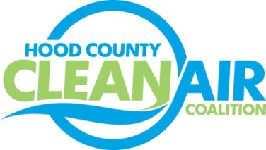
Meeting: Tuesday, September 2, 2014
American Town Hall
220 N. Travis Street, Granbury, Texas 76048
8:30-10:00 a.m.

Agenda

- Call Meeting to Order
- EPA updates – Carrie Paige
  - Review of the 2008 Ozone Standard
  - Status of the Implementation Rule for the 2008 Ozone Standard
  - Designations under the PM Standard
  - Petition to Redesignate 57 areas under the 2008 Ozone Standard and EPA’s Response
- Regional updates – Chris Klaus
a.) TCEQ Drayage Truck Incentive Program Workshop – September 4, 1:30 at NCTCOG
b.) National Drive Electric Week – September 15-20, www.dfwcleancities.org/ndew
c.) Idling Restrictions Letter
d.) Clean Fleet Policy Update. Please Provide Comments to Lori Clark, lclark@nctcog.org
e) Funding Opportunities for Vehicles: www.nctcog.org/aqfunding
f.) Clean Cities Update; more information at www.dfwcleancities.org
- Next Meeting: September 30 (accessible by web/conference call)
- Propane Technician Training in November
- Local updates – Michelle McKenzie
  - North Texas Commission Webinar Report
  - Air Quality Technical Meeting Report
  - Renewal of TCEQ Contract for Monitor Location
  - Ozone Season Update
  - Rider 8
    - Status and Review of Projects
    - Expense Approval Process
    - Consider Transfer of Coalition Funds from Lake Granbury EDC to Granbury Administration
    - Regional Air Quality Planning Workshop in Austin Report
- Discussion
- Adjourn

